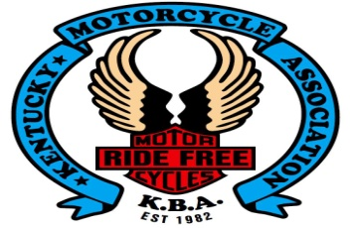
1st Annual
“Running with the Hounds”
Poker Run /Silent Auction
May 19th (rain date May 26th)
175 Trojan Trail Glasgow
Sign-up starts at 10:00 am, kick stands up at 12:00 pm
Bikes will return at 4:00 pm with a meal, silent auction & 50/50 drawing.
$15 per rider which includes a t-shirt, poker hand & meal.
Additional poker hands are $10 (max payout $250).
ALL MONEY RAISED WILL GO TO BENEFIT BRAWA
You do not have to ride to participate.
Come on out and help us support homeless animals in need! Ride overseen by KBA District 9
Any questions please call, Hershel Thomas at (270)670-8418

